**ASSIGNMENT – 1**

**Subject: CSW2 (CSE 2141)**

**Name: Arpit Kumar Mohanty**

**Registration Number: 2341013237**

**Section: 23412G1**

**Branch: CSE**

**Q1. Write a Java program with a Car class having private fields (make, model), a parameterized constructor, getter, and setter methods. In the CarTester class, instantiate myCar1 with values and myCar2 with null. Print their initial details, update myCar2 using setters, and print the updated details.**

**Solution along with Output:**

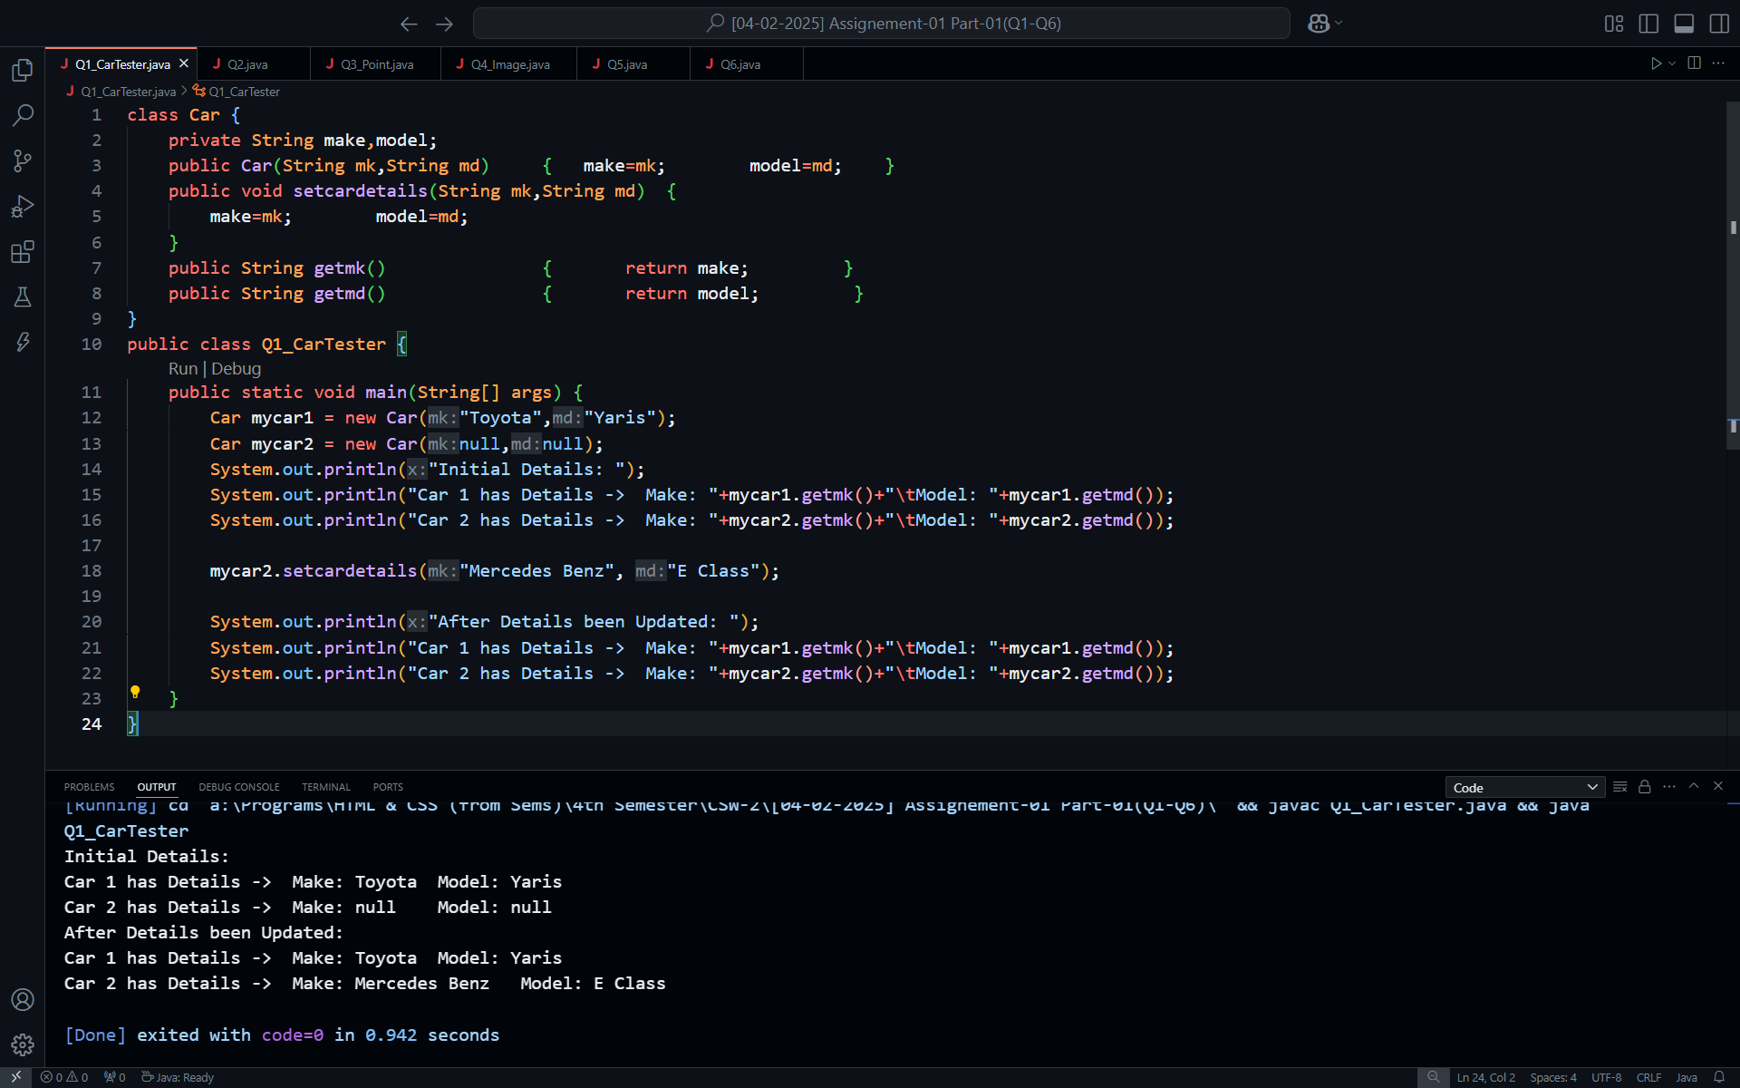

**Q2.** **Design a Java class called Rectangle with private attributes length and width. Include a constructor to initialize these attributes, as well as setter and getter methods for each attribute. Additionally, implement methods to calculate the area and perimeter of the rectangle. Write a main method to create an object of the Rectangle class, set values for its attributes, and display the area and perimeter.**

**Solution along with Output:**

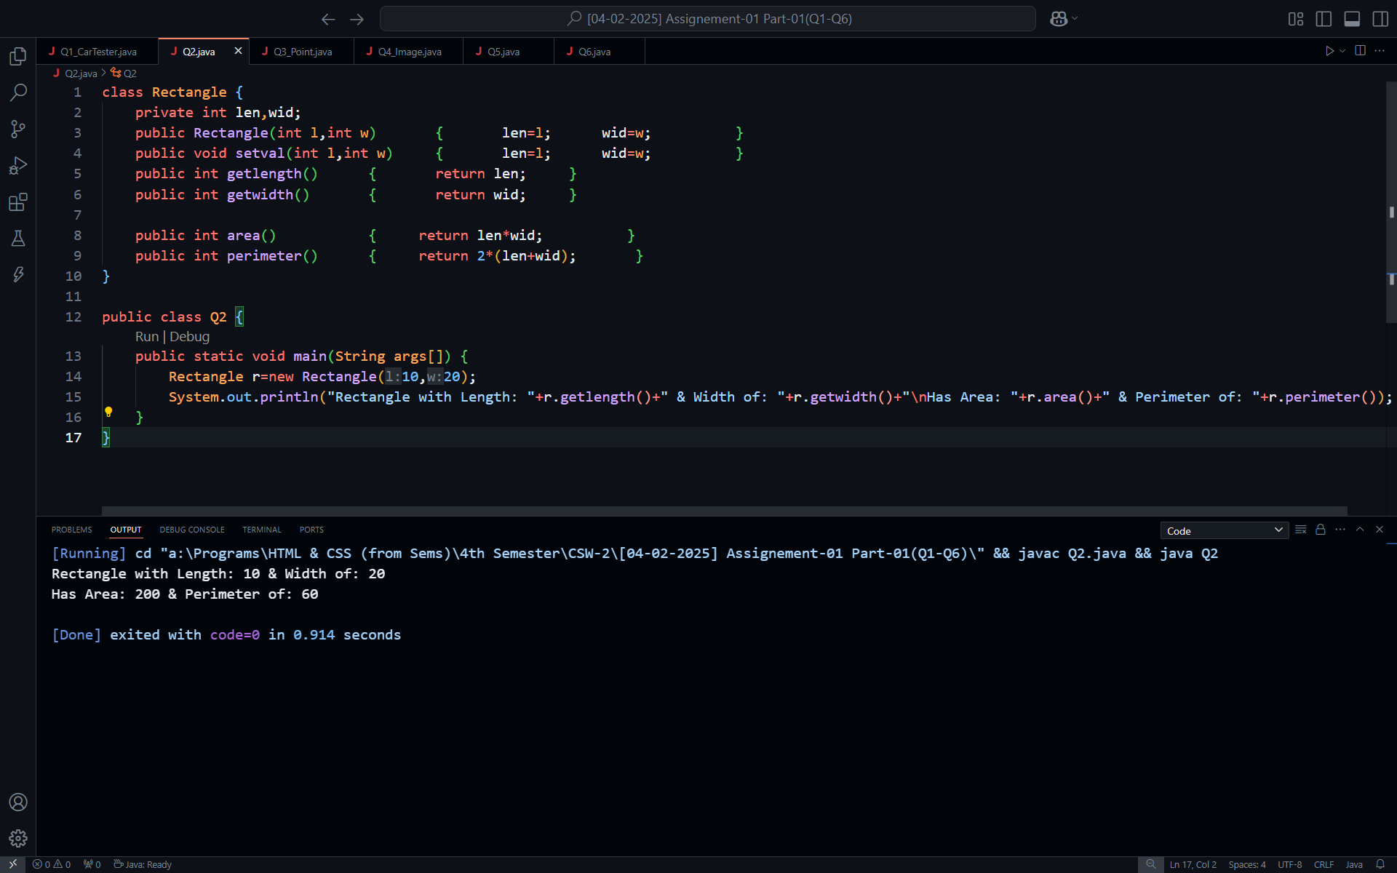

**Q3.** **Write a Java program that defines a Point class with attributes X and Y, and includes a parameterized constructor to initialize these attributes. Implement a copy constructor to create a new point object with the same attribute values. Ensure that modifications made to one object do not affect the other. Utilize getter and setter methods to retrieve and update the attribute values.**

**Solution along with Output:**

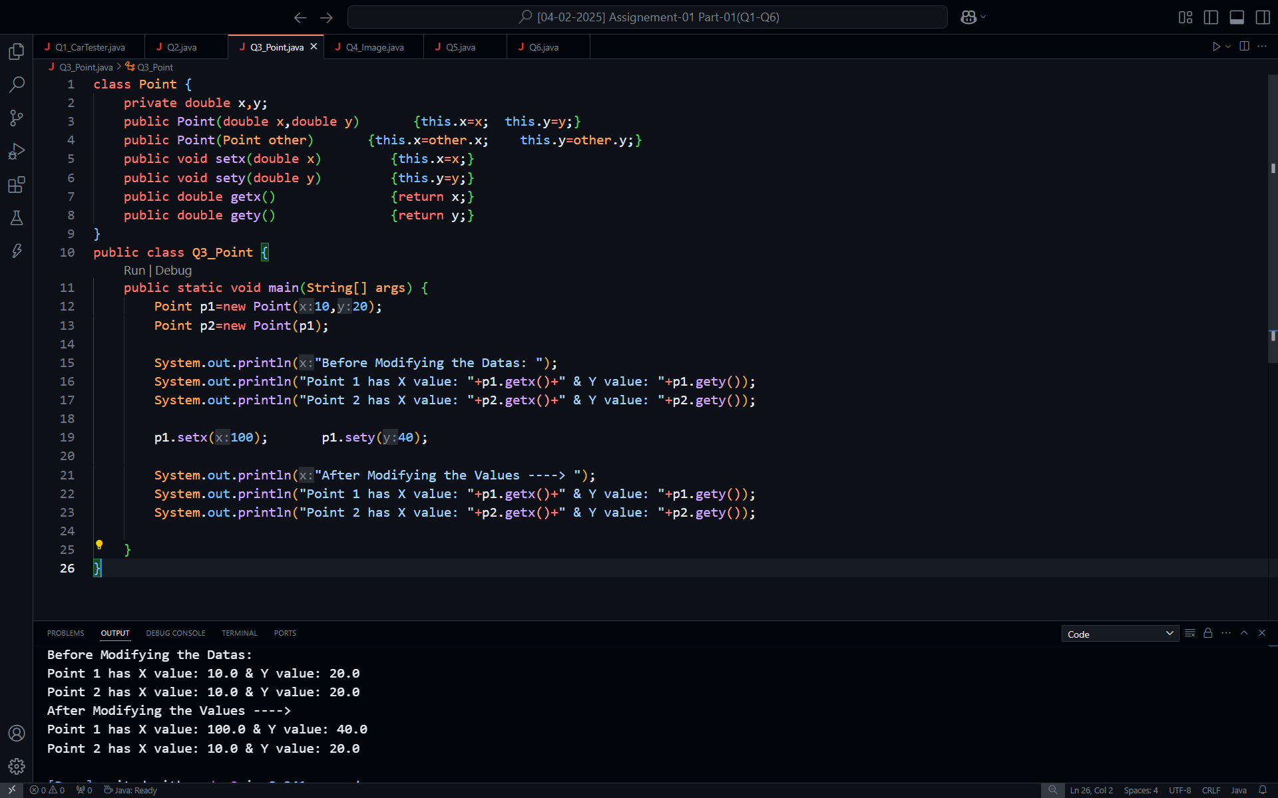

**Q4. Write a program to create an Image class with attributes imageWidth, imageHeight, and colorCode. Add the required constructor, set methods, get methods, and toString method. Create the object of the image class using the default and parameterized constructor and print the details of the object.**

**Solution along with Output:**

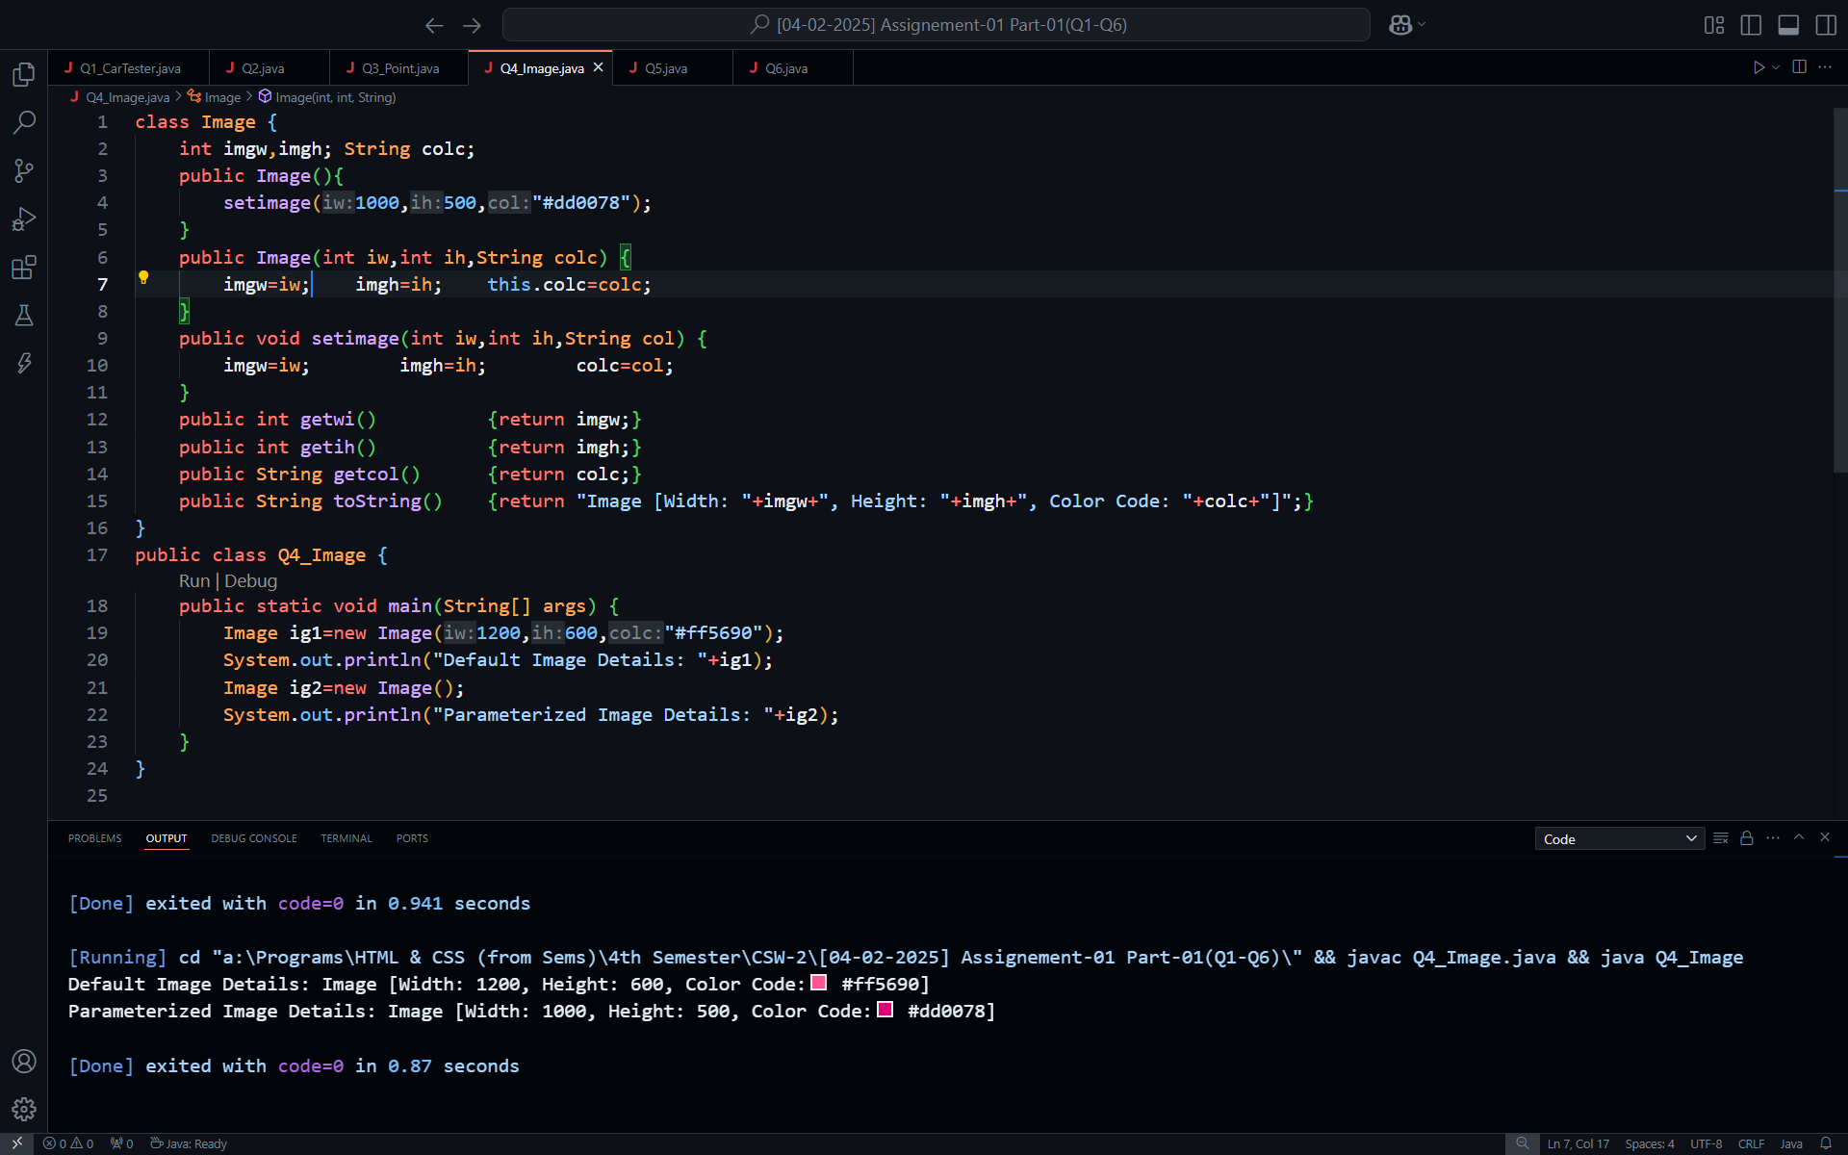

**Q5. Create an ImageLibrary, which contains a set of image objects (from Q4) and operations such as searching an image, inserting an image, and getting an image. Create an ImageController class to manage the program execution and call the methods to create and manipulate images.**

**Solution:**

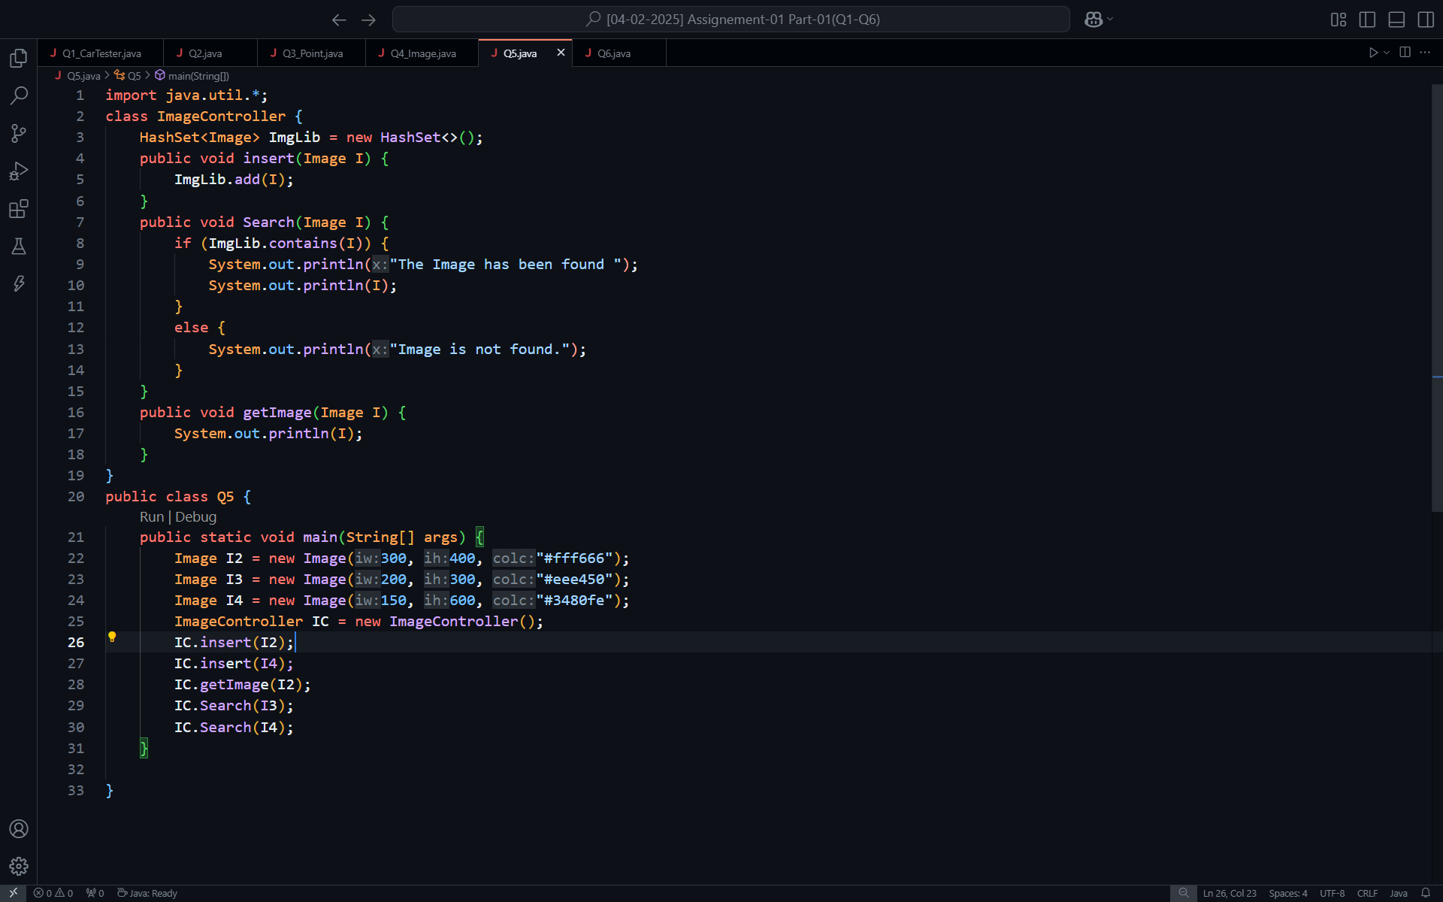

**Output:**

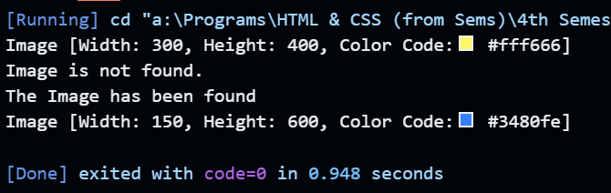

**Q6.** **Develop a Java-based College Management System to model the relationship between colleges and students. Create a College class with attributes collegeName and collegeLoc, and a Student class with studentId, studentName, and a reference to a College object. Implement a constructor in Student to initialize these attributes and a displayStudentInfo() method to print student and college details. In the MainApp class, instantiate at least two College and Student objects enroll each student in one of the colleges, and display all details using appropriate methods.**

**Solution:**

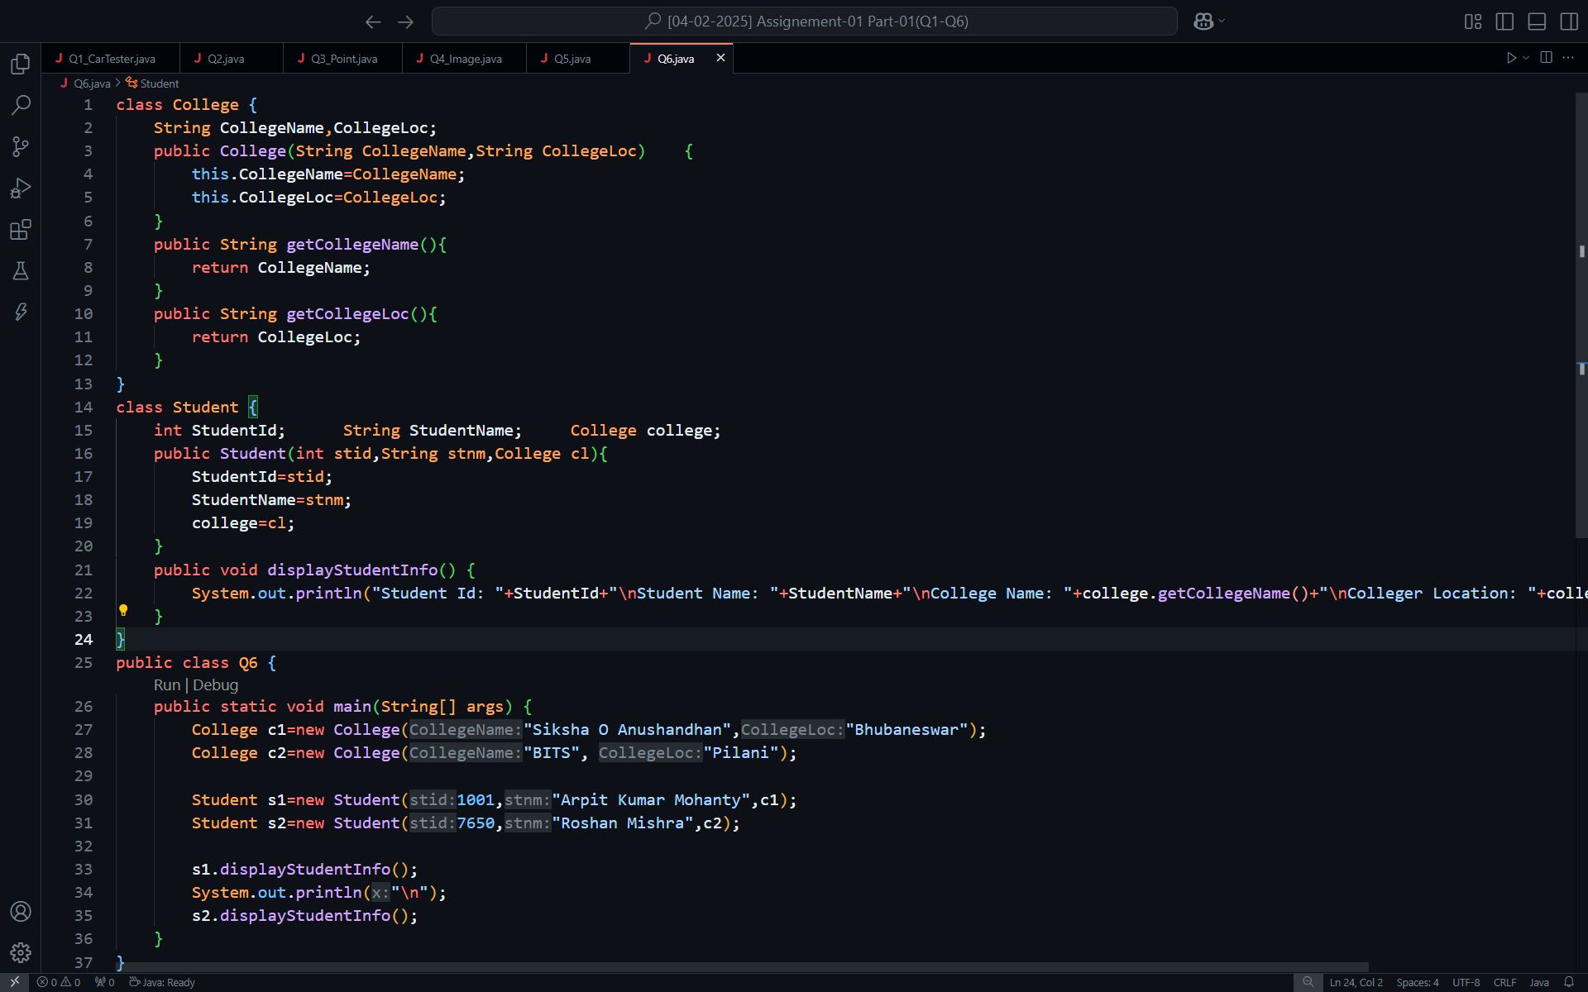

**Output:**

